CS 499 Module One Assignment Template

- Self-Introduction: Address all of the following questions to introduce yourself.

  - How long have you been in the Computer Science program?
I have been enrolled in the Computer Science program at Southern New Hampshire University for about a year. Throughout this time, I have progressed from foundational programming courses to advanced topics in software engineering, algorithms, databases, and system architecture

  - What have you learned while in the program? List three of the most important concepts or skills you have learned.
- Full-Stack Development and Software Architecture: Through courses like CS 465 and CS 340, I gained experience in building end-to-end web applications. I learned how to architect applications using the MVC pattern, implement RESTful APIs, integrate NoSQL databases like MongoDB, and create both server-side rendered applications and modern Single-Page Applications (SPAs) using frameworks like Angular and React.
- Data Structures and Algorithms: My coursework emphasized the importance of algorithmic thinking and selecting appropriate data structures for solving computational problems efficiently. I learned to implement and analyze data structures such as binary search trees, hash tables, linked lists, and graphs, as well as sorting and searching algorithms.
- Secure Software Development and Best Practices: Through courses like CS 305 I developed a security-first mindset when approaching software development. I learned to identify common vulnerabilities (such as those in the OWASP Top 10), implement secure authentication and authorization mechanisms, validate and sanitize user input, and follow industry best practices for protecting sensitive data.

  - Discuss the specific skills you aim to demonstrate through your enhancements to reach each of the course outcomes.
Course Outcome 1 - Collaborative Environments:
- Demonstrate proficiency intechnologies (MERN stack) that facilitate team collaboration
- Implement RESTful API that enables multiple developers to work on front-end and back-end independently
- Utilize version control (Git/GitHub) with commit practices and documentation
- Create well-documented, modular codemaking it accessible for team collaboration
Course Outcome 2 - Professional Communications:
- Design user-friendly interfaces following modern UI/UX principles
- Write code documentation with clear comments and annotations
- Create detailed technical narratives explaining architectural decisions
- Develop visual diagrams (flowcharts, architecture diagrams) to communicate technical concepts

Course Outcome 3 - Algorithmic Principles:
- Implement classic data structures (Binary Search Trees, Hash Tables) with proper time complexity analysis
- Develop efficient sorting algorithms (Merge Sort) and selection algorithms (Quick Select)
- Demonstrate understanding of algorithm optimization through Big O analysis
- Apply algorithmic thinking to real-world problems (animal rescue matching, data filtering)
Course Outcome 4 - Well-Founded Techniques:
- Utilize modern development frameworks and tools (React, Node.js, Express, MongoDB)
- Implement industry-standard design patterns (MVC, Repository Pattern, Service Layer)
- Apply professional development practices (testing, error handling, logging)
- Showcase mobile development skills with Android and backend integration
Course Outcome 5 - Security Mindset:
- Implement JWT-based authentication with secure token management
- Apply input validation and sanitization to prevent injection attacks
- Design secure database schemas with proper access control
- Implement password hashing using industry-standard algorithms (bcrypt)
- Configure secure API endpoints with rate limiting and authorization middleware
- Follow OWASP security guidelines throughout development

  - How do the specific skills you will demonstrate align with your career plans related to your degree?
My career goal is to become a full-stack software engineer. The skills I will demonstrate through this capstone directly align with this objective in several ways:

Technical Proficiency: By migrating to MERN stack (MongoDB, Express, React, Node.js), I am demonstrating proficiency in one of the most in-demand technology stacks in the industry.

Problem-Solving and Algorithmic Thinking: Employers value developers who can not only write code but also solve complex problems efficiently. By implementing data structures and algorithms and analyzing their performance characteristics, I demonstrate fundamental computer science knowledge.

Full-Stack Versatility: My enhancements span front-end development (React UI/UX), back-end architecture (Node.js/Express APIs), and database design (MongoDB). This versatility makes me a valuable asset to development teams, as I can contribute across the entire technology stack and understand how different components integrate.

Mobile Development Experience: The Android Weight Tracker enhancement demonstrates my ability to work with mobile platforms.

Security Consciousness: As cybersecurity threats continue to grow, companies increasingly prioritize developers with security expertise. My security mindset makes me a more attractive candidate.

Professional Development Practices: Through implementing testing, documentation, version control, and code quality tools, I demonstrate readiness to work in professional development environments.

  - How does this contribute to the specialization you are targeting for your career?
I am targeting a specialization in Full-Stack Web Development with a focus on Modern JavaScript Frameworks. My capstone enhancements contribute to this specialization in the following ways:

MERN Stack: By converting the CS 340 project from Python/Dash to a MERN stack application, I am demonstrating deep knowledge of the complete JavaScript ecosystem.

React: Building a React application with modern hooks, component architecture, and state management demonstrates my specialization in one of the most popular front-end frameworks.

Node.js Backend Development: Creating RESTful APIs with Express.js and implementing authentication, validation, and error handling showcases my ability to build production-ready backend services.

NoSQL Database: Working with MongoDB (both in the CS 340 enhancement and CS 360 migration) positions me as a developer who understands modern, schema-flexible database solutions.

- ePortfolio Set Up:

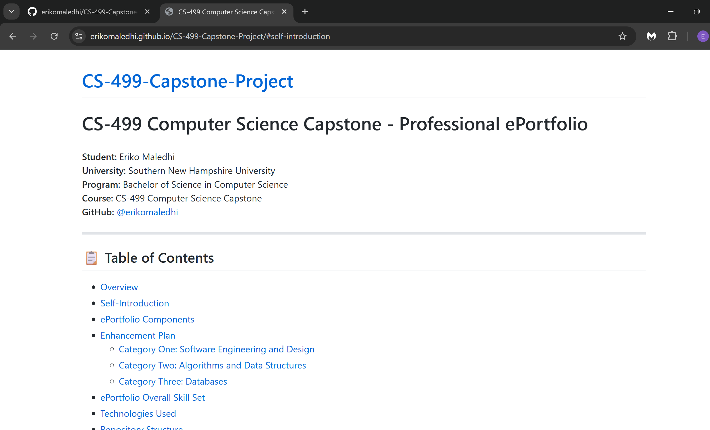

- Enhancement Plan:

  - Category One: Software Engineering and Design
    - Select an artifact that is aligned with the software engineering and design category and explain its origin. Submit a file containing the code for the artifact you choose with your enhancement plan.

CS 340: Grazioso Salvare Animal Rescue Dashboard

The Grazioso Salvare Dashboard is a data visualization and filtering application originally developed using Python, the Dash framework, Plotly for charts, and MongoDB for data storage. The application was designed for Grazioso Salvare, a company specializing in training rescue animals, to help identify suitable dogs for different rescue operations.

The current implementation includes:
- A Python-based CRUD module (animal_shelter.py) using PyMongo for MongoDB operations
- A Dash-based dashboard (ProjectTwoDashboard.ipynb) with interactive filtering
- A data table with sorting and pagination
- A pie chart showing breed distribution
- An interactive geolocation map with animal locations
- Radio button filters for different rescue types

Why This Artifact:
I selected this artifact for the Software Engineering and Design category because it provides a GOOD foundation for demonstrating architectural transformation. The current Python/Dash implementation, while functional, represents a more traditional server-side approach. By converting this to a MERN stack application, I can showcase my ability to:
- Re-architect an existing application using modern design patterns and industry-standard technologies
- Implement separation of concerns through proper MVC architecture
- Build RESTful APIs
- Create reusable, component-based UI using React
- Apply modern development practices including error handling, validation, logging, and testing

    - Describe a practical, well-illustrated plan for enhancement in alignment with the category, including a pseudocode or flowchart that illustrates the planned enhancement.

I will transform the Python/Dash dashboard into a full-stack MERN (MongoDB, Express, React, Node.js) application with enhanced architecture, modern UI/UX, and industry-standard development practices.

Planned Enhancements:

1. Backend Architecture (Node.js + Express.js)
Transform the simple Python CRUD module into a professional RESTful API with:

- Express.js server with modular routing structure
- Mongoose ODM for MongoDB integration with schema validation
- Error handling with custom error classes
- JWT-based authentication for admin operations

2. Frontend Architecture (React.js)
Rebuild the Dash interface as a modern React Single-Page Application:

- Component-based architecture with reusable UI elements
- React Router for client-side navigation
- Context API or Redux for state management
- Custom hooks for data fetching and business logic
- Material-UI or Tailwind CSS for professional styling
- Form validation with real-time feedback

3. Professional Development Practices
- Prettier for code quality and consistency
- Proper Git workflow with meaningful commits
- README documentation with setup instructions
- API documentation with clear endpoint descriptions
- Code comments following JSDoc standards

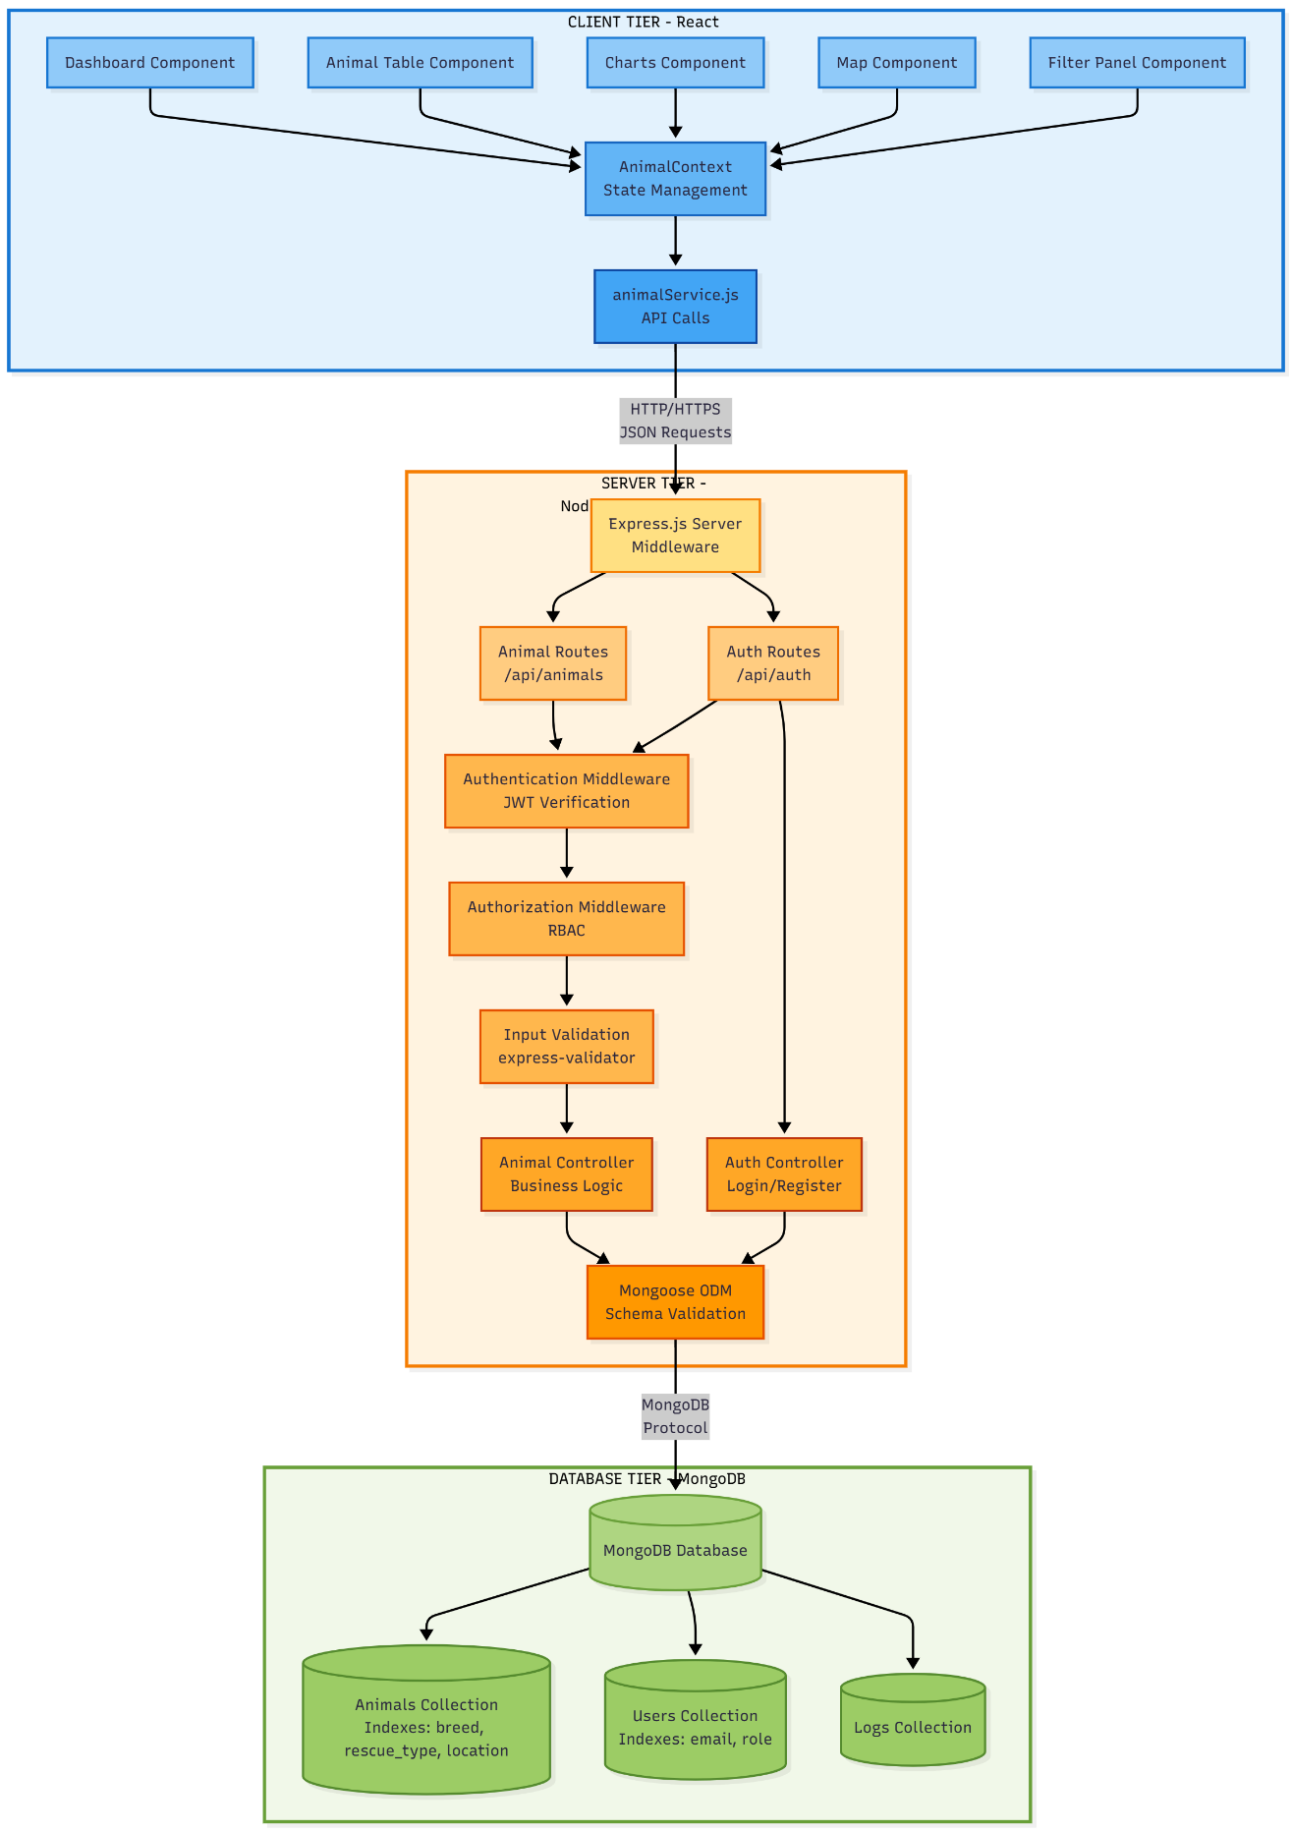

    - Explain how the planned enhancement will demonstrate specific skills and align with course outcomes.

      - Identify and describe the specific skills you will demonstrate that align with the course outcome.

1. Full-Stack Web Development:
- Building complete MERN stack applications from scratch
- Creating RESTful APIs
- Implementing client-server architecture with clear separation of concerns
- Integrating front-end and back-end through HTTP protocols and JSON data exchange
2. Software Architecture and Design Patterns:
- Model-View-Controller (MVC) architectural pattern
- Component-based architecture in React
3. Database Design and Integration:
- NoSQL database schema design with Mongoose
- Creating efficient database queries and indexes
- Implementing data validation at multiple layers (client, server, database)
4. API Design and Development:
- RESTful API principles and HTTP methods (GET, POST, PUT, DELETE)
- API versioning and documentation
5. Security Best Practices:
- JWT (JSON Web Token) authentication implementation
- Role-Based Access Control (RBAC) for authorization
- Input validation and sanitization to prevent injection attacks
- Secure password handling with hashing (bcrypt)
6. Front-End Development:
- React component lifecycle and hooks
- State management with Context API
- Client-side routing with React Router
- Responsive design principles and CSS frameworks
- Data visualization with Chart.js/Recharts
- Interactive mapping with Leaflet
7. Professional Development Practices:
- Code organization and project structure
- Error handling and logging strategies
- Environment configuration management
- Code documentation and commenting standards
- Version control with Git (branching, committing, merging)
- Code quality tools (ESLint, Prettier)
8. Testing and Debugging:
- API testing strategies (Postman, manual testing)
- Understanding and fixing runtime errors

9. Technical Communication:
- Writing clear technical documentation
- Creating architectural diagrams and flowcharts
- Documenting APIs with examples and usage instructions

      - Select one or more of the course outcomes below that your enhancement will align with.

Course Outcome 1: Employ strategies for building collaborative environments that enable diverse audiences to support organizational decision-making in the field of computer science.

Alignment:
- Industry-Standard Technologies: By using the MERN stack, I am working with technologies widely adopted in the industry, making the codebase immediately familiar to other developers and facilitating team collaboration.
- RESTful API Design: Creating a well-documented REST API allows front-end and back-end developers to work independently
- Modular Architecture: The separation of concerns (routes, controllers, services, models) allows different team members to own different parts of the codebase without conflicts.
- Clear Documentation: Code comments and API documentation enable team members and stakeholders to understand the system quickly.
- Version Control: Git practices with meaningful commits make collaboration easier and track decision-making history.

Course Outcome 2: Design, develop, and deliver professional-quality oral, written, and visual communications that are coherent, technically sound, and appropriately adapted to specific audiences and contexts.

Alignment:
- User Interface Design: Creating a visually appealing dashboard demonstrates my ability to communicate complex data visually to non-technical stakeholders.
- Technical Documentation: Writing clear API documentation, code comments, and architectural explanations shows my ability to communicate technically information to developer audiences.
- Code Quality: Clean, well-organized code with consistent naming conventions and formatting demonstrates professional communication through code itself.
- Visual Diagrams: Creating architecture diagrams, flowcharts, and component structures provides visual communication of system design to diverse audiences.
- Error Messages: Implementing user-friendly error messages and validation feedback demonstrates communication.

Course Outcome 4: Demonstrate an ability to use well-founded and innovative techniques, skills, and tools in computing practices for the purpose of implementing computer solutions that deliver value and accomplish industry-specific goals.

Alignment:
- Modern Framework Adoption: Utilizing the MERN stack represents current industry best practices for building web applications.
- Design Patterns: Implementing MVC patterns demonstrates knowledge of well-founded software engineering techniques.
- Professional Tools: Using Express.js, Mongoose, JWT authentication, and validation libraries demonstrates proficiency with industry-standard tools.

Course Outcome 5: Develop a security mindset that anticipates adversarial exploits in software architecture and designs to expose potential vulnerabilities, mitigate design flaws, and ensure privacy and enhanced security of data and resources.

Alignment:
- Authentication Implementation: JWT-based authentication prevents unauthorized access to administrative functions.
- Authorization (RBAC): Role-based access control ensures users can only perform actions appropriate to their privilege level.
- Input Validation: Multi-layer validation (client-side, server-side, database-level) prevents injection attacks and data corruption.
- Secure Password Handling: Using bcrypt for password hashing ensures user credentials are protected even if the database is compromised.
- Error Handling: Careful error messages that don't expose sensitive system information prevent information leakage.
- Logging: Security event logging (unauthorized access attempts) enables monitoring and incident response.

  - Category Two: Algorithms and Data Structures

- Select an artifact that is aligned with the algorithms and data structures category and explain its origin. Submit a file containing the code for the artifact you choose with your enhancement plan. You may choose work from the courses listed under Category One.

CS 340: Grazioso Salvare Animal Rescue Dashboard

I have selected the Grazioso Salvare Animal Rescue Dashboard as my artifact for the Algorithms and Data Structures category. This is the same artifact I am using for the Software Design and Engineering category, as it provides a goodfoundation for demonstrating multiple aspects of computer science expertise within a singleproject.

Current Limitations Regarding Algorithms and Data Structures:
- Linear Search Operations: All filtering and searching operations iterate through the entire dataset sequentially, resulting in O(n) time complexity for every search operation.
- No Data Structure Optimization: The application uses basic Python lists and dictionaries without leveraging advanced data structures that could improve performance.
- Inefficient Sorting: When sorting animals by breed, age, or other criteria, the application uses Python's built-in sort without implementing custom algorithms optimized for the specific use case.
- No Caching Mechanism: Repeated queries for the same data (e.g., "show me all Water Rescue dogs") fetch from the database each time, with no intelligent caching to reduce redundant operations.

Why This Artifact:
- Real-World Dataset: With over 10,000 animal records, performance improvements from better algorithms are measurable and meaningful
- Multiple Search Criteria: The need to search by ID, breed, age, rescue type, and location provides opportunities to implement different data structures optimized for different query types
- Quantifiable Performance: I can measure and document the time complexity improvements (e.g., from O(n) to O(log n) or O(1))

- Describe a practical, well-illustrated plan for enhancement in alignment with the category, including a pseudocode or flowchart that illustrates the planned enhancement.

Enhancement 1: Binary Search Tree (BST) for Animal ID Lookup

Purpose: Enable efficient O(log n) average-case search time for looking up animals by their unique identifier, compared to the current O(n) linear search.

Use Case: When a user clicks on an animal in the table to view detailed information, the system must quickly retrieve that specific animal's complete record using its ID.

Enhancement 2: Hash Table for Breed Lookup

Purpose: Achieve O(1) average-case lookup time for finding all animals of a specific breed, enabling instant filtering by breed type.

Use Case: When users filter the dashboard by breed (e.g., "Show me all Labrador Retrievers"), the system must instantly retrieve all matching animals.

- Explain how the planned enhancement will demonstrate specific skills and align with course outcomes.

  - Identify and describe the specific skills you will demonstrate to align with the course outcome.

Algorithm Implementation:
- BST recursive/iterative operations
- Hash function design with collision handling
- Divide-and-conquer (merge sort)
- Partitioning algorithms (quickselect)
Complexity Analysis:
- Big O notation for all operations
- Best/average/worst case analysis
- Time vs. space trade-offs
Data Structure Selection:
- BST for ordered data with range queries
- Hash table for categorical lookups
- Merge sort for stable sorting
- QuickSelect for top-N problems
Professional Practices:
- Algorithm documentation
- Unit testing (edge cases, performance)
- Code optimization

  - Select one or more of the course outcomes listed under Category One that your enhancement will align with.

Outcome 3: Algorithmic Principles
- Design solutions using classical algorithms (BST, hash tables, merge sort)
- Analyze time/space complexity with Big O
- Manage trade-offs (BST O(log n) vs Hash O(1), stable vs unstable sort)
- Compare alternatives with justification

Outcome 2: Professional Communication
- Pseudocode with complexity annotations
- Performance benchmarking with clear metrics

Outcome 4: Well-Founded Techniques
- Classical algorithms (von Neumann merge sort, Hoare quickselect)
- Measurable value: 5-35x performance improvements

  - Category Three: Databases

    - Select an artifact that is aligned with the databases category and explain its origin. Submit a file containing the code for the artifact you choose with your enhancement plan. You may choose work from the courses listed under Category One.

CS 360: Weight Tracker Android Application

Current State:
- Android app using SQLite local database
- Three tables: Users, WeightEntries, Goals
- All data stored on device only

Why Enhance:
Migrate to MongoDB to demonstrate NoSQL database design and modern database practices.

    - Describe a practical, well-illustrated plan for enhancement in alignment with the category, including a pseudocode or flowchart that illustrates the planned enhancement.

Migration: SQLite → MongoDB
Core Changes:
- Replace SQLite tables with MongoDB collections
- Redesign schema using NoSQL best practices
- Create indexes for query optimization
- Implement aggregation pipelines for analytics
- Add REST API (simple Express.js) to connect Android app to MongoDB

    - Explain how the planned enhancement will demonstrate specific skills and align with course outcomes.

      - Identify and describe the specific skills you will demonstrate that align with the course outcome.

NoSQL Database Design:
- Document-based schema vs. relational tables
- Embedded documents (denormalization)
- Reference patterns (one-to-many relationships)
- Data type optimization (Date vs TEXT)
MongoDB Expertise:
- CRUD operations with MongoDB Java Driver
- Aggregation pipeline syntax
- Index creation and optimization
- Query performance analysis
Database Migration:
- ETL process (Extract from SQLite, Transform, Load to MongoDB)
- Data type conversion (TEXT dates → Date objects)
- Foreign key → ObjectId reference mapping
- Data validation post-migration
Performance Optimization:
- Single-field indexes for unique constraints
- Compound indexes for multi-field queries
- Index selection strategy (when to use which index)

      - Select one or more of the course outcomes listed under Category One that your enhancement will align with.

Outcome 4: Well-Founded Techniques
- MongoDB is industry-standard NoSQL database
- Demonstrates modern document-based design
- Aggregation pipelines are MongoDB best practice
- Local MongoDB useful for development/testing environments
Outcome 5: Security
- Password hashing (bcrypt) instead of plain text
- Input validation for database operations
- NoSQL injection prevention (parameterized queries)
Outcome 2: Professional Communication
- Schema diagrams comparing SQL vs NoSQL
- Migration documentation
- Query comparison examples
- Index justification

- ePortfolio Overall Skill Set

  - Accurately describe the skill set to be illustrated by the ePortfolio overall.
    - Skills and outcomes planned to be illustrated in the code review

The code review video will demonstrate my ability to analyze existing code and communicate technical concepts to both peers and managers. I will walk through two artifact, he CS 340 Grazioso Salvare Dashboard and the CS 360 Weight Tracker application, identifying their current functionality, strengths, and weaknesses. For the Grazioso Salvare Dashboard, I will explain how the Python/Dash implementation currently uses basic linear search operations with O(n) complexity and lacks optimized data structures, making it slow with large datasets. I will articulate why converting this to a MERN stack application with Binary Search Trees, Hash Tables, and efficient sorting algorithms will improve performance by 5-30x. For the Weight Tracker app, I will demonstrate the limitations of the current SQLite local-only database and explain how migrating to MongoDB will enable better schema design with embedded documents, aggregation pipelines for analytics, and proper indexing strategies. Throughout the review, I will outline my enhancement plans for all three categories, Software Design and Engineering (MERN conversion with RESTful API and security improvements), Algorithms and Data Structures (implementing BST, hash tables, merge sort, and quickselect with Big O analysis), and Databases (SQLite to MongoDB migration with NoSQL schema design). This video will showcase my professional oral communication skills, my ability to evaluate code quality and performance bottlenecks, and my understanding of modern software engineering practices, aligning with Course Outcomes 2 (professional communication), 3 (algorithmic analysis), and 4 (well-founded techniques).

    - Skills and outcomes planned to be illustrated in the narratives

The enhancement narratives will demonstrate my technical writing abilities and my capacity to justify design decisions with explanations of the enhancement process, challenges encountered, and solutions implemented. For the Software Design and Engineering narrative, I will explain my architectural transformation from a Python/Dash monolithic application to a MERN stack with clear separation between client (React), server (Express.js), and database (MongoDB) tiers. I will document the implementation of JWT-based authentication, role-based access control (RBAC), input validation middleware, and security best practices following OWASP guidelines. The narrative will include before-and-after code comparisons, architectural diagrams showing the three-tier structure, and explanations of why I chose specific design patterns like MVC. For the Algorithms and Data Structures narrative, I will provide detailed explanations of each algorithm's implementation, including pseudocode, complexity analysis (time and space), and performance benchmarking results. I will justify why I selected BST for ID lookups (O(log n) vs O(n) linear search), Hash Tables for breed filtering (O(1) average case), Merge Sort for stable multi-field sorting (guaranteed O(n log n)), and QuickSelect for top-N queries (O(n) average vs O(n log n) full sort). Each algorithm will include trade-off analysis comparing alternatives I considered but rejected. For the Databases narrative, I will document the SQLite to MongoDB migration process, explaining the transformation from relational tables with foreign keys to document-based collections with ObjectId references and embedded subdocuments. I will justify design decisions like when to embed documents versus reference them, explain my indexing strategy with compound indexes for common query patterns, and demonstrate aggregation pipelines for calculating weekly weight averages and goal progress percentages. These narratives will showcase my technical documentation skills, critical thinking in design decisions, and ability to communicate complex technical concepts in writing, aligning with Course Outcomes 2 (professional written communication), 3 (algorithmic problem-solving), 4 (innovative techniques), and 5 (security mindset).

    - Skills and outcomes planned to be illustrated in the professional self-assessment

The professional self-assessment will provide a reflection on my entire Computer Science journey at SNHU.I will address the five key areas explicitly. Collaboration by explaining how the MERN stack and RESTful APIs I've implemented enable team-based development with clear separation between frontend and backend teams. Communication with stakeholders by describing how I've learned to translate technical concepts like Big O complexity into business value like "10x faster searches" and "supports 100,000 animals instead of 10,000". Data structures and algorithms by reflecting on how I've moved from basic array manipulation to implementing structures like Binary Search Trees and understanding when to apply specific algorithms based on use case and performance requirements. Software engineering and databases by discussing my evolution from simple CRUD applications to architecting systems with proper authentication, input validation, and NoSQL schema design and finally, security by explaining how I've developed a security-first mindset through implementing password hashing with bcrypt, JWT authentication with token expiration, RBAC for authorization and input sanitization to prevent injection attacks.I will articulate my career goals to become a full-stack software engineer and explain how this ePortfolio positions me for roles at companies. I will also reflect on specific challenges I overcame during the enhancements.

